Virtual Operator’s Guide
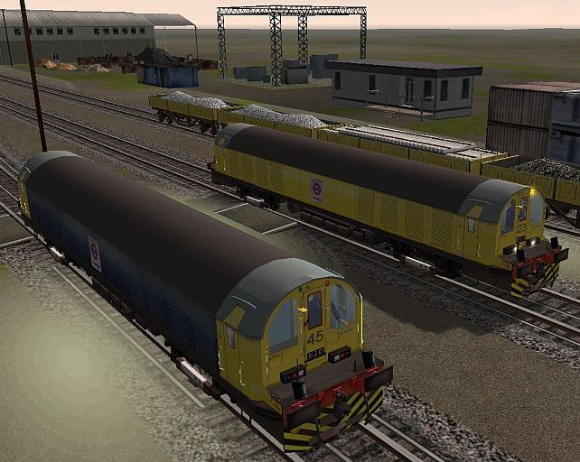
LT TransPlant Battery Locomotive for MSTS – May 2007

LUL currently maintains a fleet of 37 TransPlant-operated Battery Locomotives, these locos entering service in three batches in 1964, 1970 and 1974. They are used to haul materials – spoil, ballast and rails – to locations on the combine where after-hours maintenance work may be required. The 62 tonne locos are able to run on both 650V line voltage or on 320V supplied by internal batteries, the latter being used around the worksite where traction current would be switched off after traffic hours to allow safe access for the track workers. The picture above shows the MSTS LT Battery Locos L45 and L23, and the 40 tonne Turbot wagons depicted in Lillie Bridge Depot prior to a set being made up for the night’s work.
These Battery Locos (and the associated Turbot wagons) were produced by a team of enthusiasts that included invaluable support from a current Battery Loco operator and key contributions from other LUL professionals. Our goal was to create a realistic model of the real Battery Loco – in appearance, operation and performance. This guide is intended to help you become familiar with the loco, its controls and operation; and with practice to become a competent MSTS TransPlant Battery Loco Operator. Good luck, and enjoy!

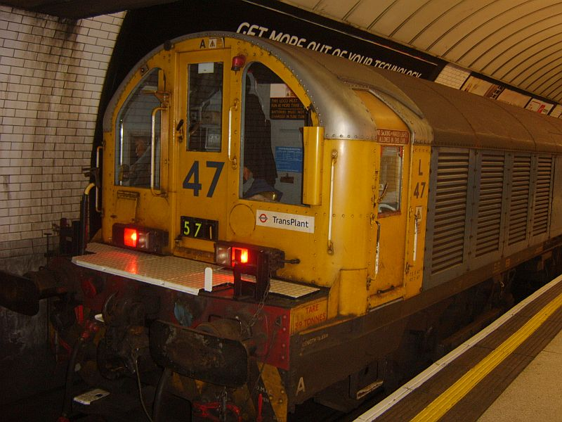
Welcome to your train
Let’s first examine the LT Battery Loco from the outside and understand how a Battery Loco train set (or consist, in MSTS terms) is made up.
A Battery Loco train is almost always formed of a lead loco, some number of wagons and a rear loco. The Turbot wagons include connectors and wiring to enable control of the rear loco from the front loco. Each loco also has both front and rear cabs, thus you can control operation from either cab of either loco as may be appropriate. This capability is included in the MSTS locos, and the method to select locos and cabs will be explained later. The number of wagons in the set will likely depend on the total weight and loads carried (i.e. loco hauling capacity), and possibly by bridge weight restrictions on parts of the combine.
The picture shows LT Battery Loco L47 at the rear of set 571 (red rear lights illuminated). As the loco can be operated from either cab and coupled from either end, both ends include multiple coupling mechanisms, buffers, cab front and side doors, and lights that can be illuminated for either front or rear orientation. Access to each end cab is through one of several doors. Hinged cab side doors provide access from the platform level. The front (or “M” door) also allows access in depot or work areas. A door in the cab rear bulkhead (“J” door) allows access through the loco, past the battery area, to the other-end cab.
The operator’s position is on the left of the cab – usually referred to as the near-side of the cab. The cab interior and controls are very austere. In place of a control desk, you will find two pedestals for the operating controls (master controller, selector and brake handle), a duplex brake air gauge, switches for the air-operated whistle and wipers, and several rear-wall control panels.
Before we explore the cab and loco controls, we’ll take a moment to look more closely at the front of the loco and identify a number of important items.
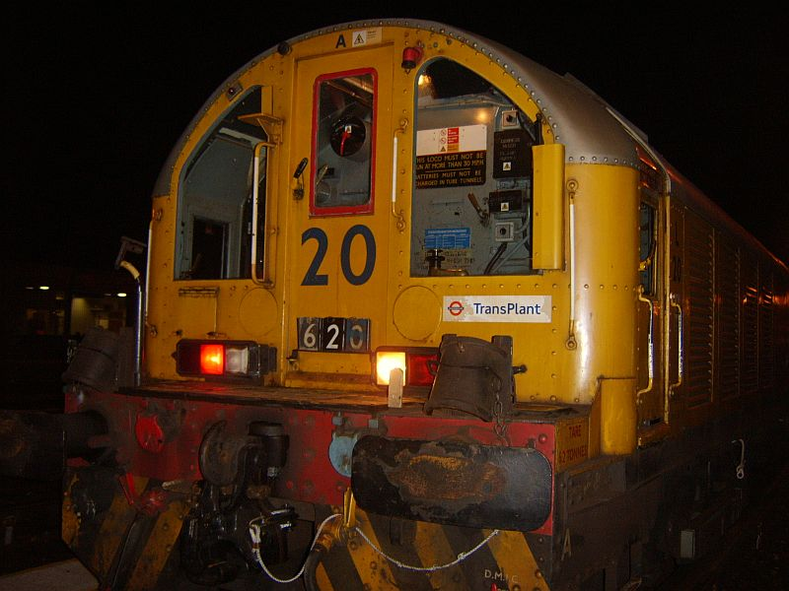

The photo above identifies some key components on the loco. The loco number (L20 in this case) is shown on the M door. The train set number (620), identifying the specific engineering train, is located near the bottom of the M door. The operator’s windows extend quite low down affording a good view close to the front of the loco making coupling operations easier to see.
The loco normally uses drophead Buckeye couplers with drawhooks, and has buffers for emergency use. An emergency wedgelock coupler is also available. Various sockets provide external power for cement mixers, for wagon-mounted compressors, and for long welded-rail car lighting and communications.
The whistle is controlled by a button to the left of the brake control stand, and is used at specific route locations (marked by Whistle Boards), or to warn Permanent Way crews working on or near the track of the train’s approach. The Battery Loco whistle and its brass control button are included in the MSTS model (controlled in MSTS by the <spacebar>). The window wiper is hidden behind a screen when not in use. It is animated in the MSTS train and is controlled by the “V” key.
The lights used depend on if the train is in service, and whether the unit is currently a ‘front’ or ‘rear’ unit (white headlights or red taillights illuminated as required). In the picture above, one white and one red light are shown illuminated. Normally two white lights would be used on the front unit and two red lights on the rear unit. An amber rotating beacon can also be seen to the upper-nearside of the M door. The operation of the lighting with the MSTS train is discussed in a later section titled Train Lights.

An Overview of the Cab
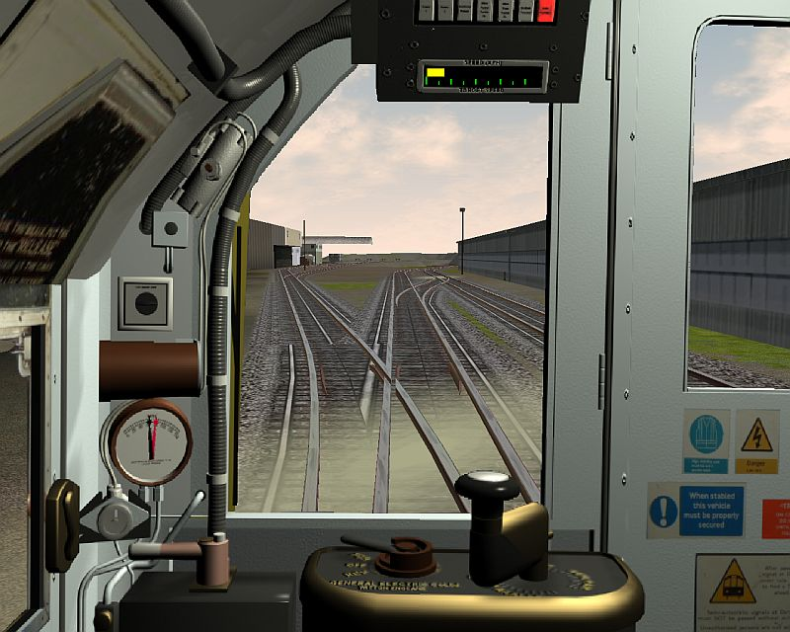
This is where you’ll be spending most of your time – the MSTS Battery Loco cab – viewed from the operator’s position. There are various displays, switches and gauges, and two sparse control stands. Following sections will illustrate the main cab features. Of particular interest are:
- A panel above the window containing ATO-related equipment, including a bar-type speedometer showing both target and actual speeds. The red “Code Available” light is lit.
- The Drivers Brake Handle (DBH) controlling the brake system, operated by the operator’s left hand; and an associated duplex air pressure gauge.
- The selector enabling Forward, Off and Reverse selections.
- The motoring control (Master Controller) operated by the operator’s right hand. This controller is unique – the brass legend depicts Series, Series-Parallel and Parallel motoring with each group having 9 marked positions, as there is no automatic notching relay-controlled RPA acceleration system in the real loco. We have simplified the control somewhat in the MSTS loco.
- The wiper control, just below-left of the duplex gauge.
- The brass whistle button to the left of the brake control stand.

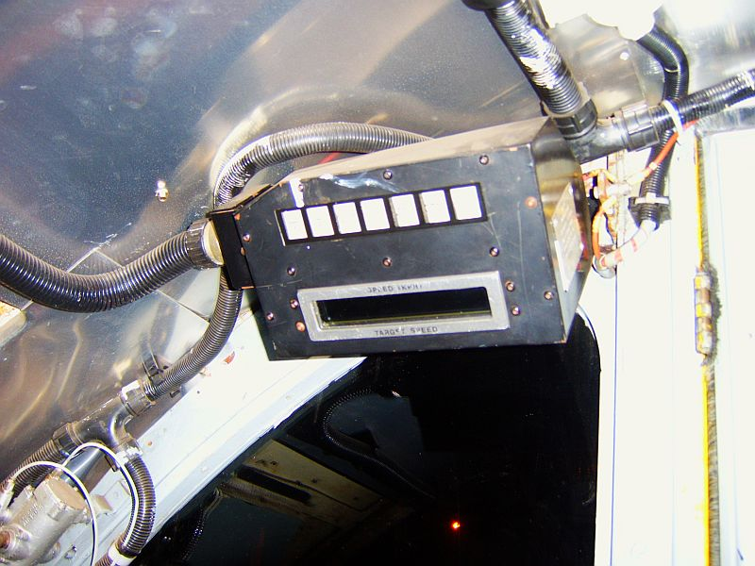
ATO EQUIPMENT BOX
The photo shows the ATO equipment box in the real loco. This equipment is required as these locos often have to travel on sections of the combine where ATO signaling is employed. Two bar-type displays indicate actual speed (upper yellow bar) and ATO target speed (lower green bar). The target speed bar currently displays ‘signaled speed’ in the MSTS loco, and the right-hand light (Code received) is always illuminated red. The MSTS bar display includes a series of small/large tick marks showing 5 and 10 mph intervals, as it was not possible to show the real unit’s numeric values with sufficient detail in the MSTS loco. A future version of MSTS BIN will allow showing ‘speed limit’ speed, which will be as realistic as we can simulate for ATO target speed. A cab displays update will be issued for this loco once this new MSTS BIN display has been implemented and tested.

CAB CONTROLS
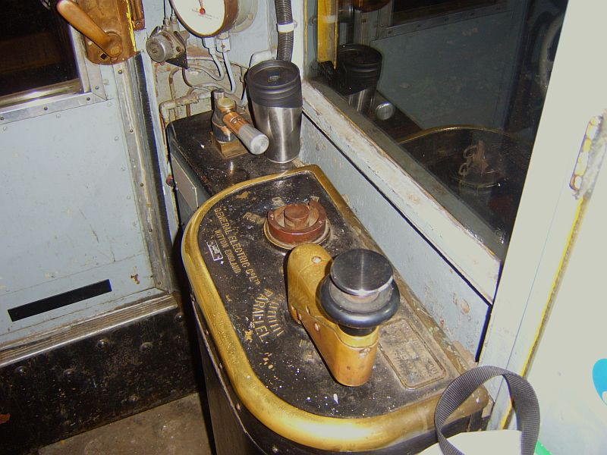
The photo shows the main operator’s controls. From right to left…
The Master Controller is shown in the OFF position with the deadman button raised. Moving the handle clockwise will select successive motoring notch groups (Series, Series-Parallel and Parallel) with each group having 9 marked positions in the real loco, used to switch out the resistors. Thus you have a total of 27 motoring positions! Anecdotal information suggests that not all ‘notches’ are used in real life, and that the controller is not left in a ‘resistor notch’ for more than about 10 seconds due to resistive heat. The Operator is effectively doing manually what the automatic acceleration equipment (notching relays and RPAs) do in many LUL DM stocks, with regards to switching out resistor banks.
The Selector has Forward, Off and Reverse. The selector handle is shown removed in the photo.
The Driver’s Brake Handle is further to the left (with a coffee mug leaning on it). It is shown in the Shutdown position (handle at 3 o’clock). The Off position is at 9 o’clock, and moving the handle anti-clockwise applies increased braking until about the 5 o’clock position. Emergency is at about 4 o’clock. The Shutdown position can not be simulated in the MSTS loco.
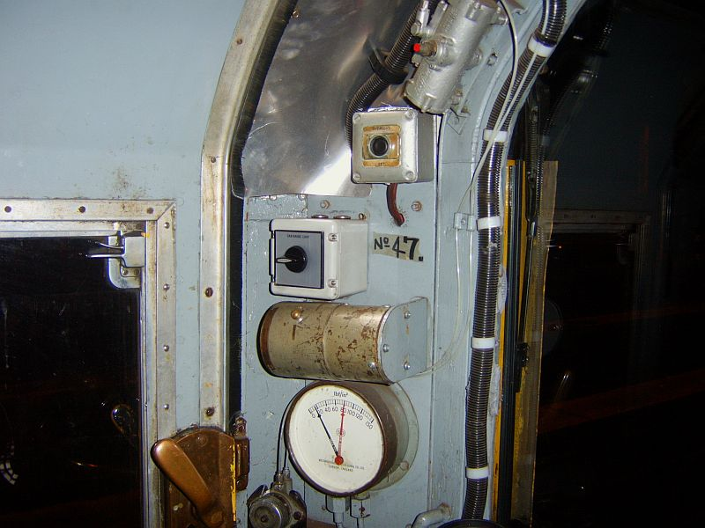
To the left of the Operator’s front window are the Duplex Air Gauge, light switches and the Wiper Control Switch.
The Duplex Gauge has two needles. The red needle indicates main reservoir pressure, and the black needle shows brake line pressure. As you apply the train brakes the black needle will show a fall in pressure depending on the amount of braking. When the brakes are released the black needle will rise to its normal pressure and the red needle will fall slightly as the main reservoir re-charges the brake line. If the red needle falls sufficiently, it will trigger the compressors to re-charge the main reservoir. You will hear the compressors and see the red needle rise to its nominal pressure.

Train Operation & Controls
Your first job as a Battery Loco Operator would be to open up the loco for service. This process is usually accomplished in the Depot and involves a set of prescribed procedures to make the loco ready for use -- these procedures ensuring that all equipment is operational and that the train can be motored. In the MSTS simulation, there are a few operations required before bringing the train into service that are intended to mimic these real-life procedures.

OPENING UP THE MSTS BATTERY LOCO FOR SERVICE
When you enter the Battery Loco train at the start of an MSTS activity or route exploration, the Selector (MSTS Reverser) will be in the OFF (Neutral) notch, the DBH will have a degree of braking applied, the Master Controller will be OFF, and the MSTS train lights switch will be OFF. You will also hear the air compressors bringing up the air pressure to its nominal value and see the duplex air gauge red needle rise to about 85psi. Before being able to motor the loco and begin your activity you will need to execute a few simple steps. You may also wish to review your Activity briefing to see what your simulated working entails.

TRAIN LIGHTS
The MSTS Battery Loco lights are controlled by the “H” and “Shift-H” keys. As all the train lights are currently OFF, you will need to press “H” once to turn on appropriate train lighting – i.e. turn on the front white lights and the rear red lights. Pressing “H” again will also illuminate the flashing amber beacon lights. Pressing “Shift-H” will progressively cycle the lighting back to OFF. The normal procedure, therefore, will be to turn on the correct front/rear train lights by pressing “H” once. You can use the exterior front and rear MSTS views (normally the “2” and “3” views) to confirm that the front and rear unit lights are operating. This simulates the real-life “walk around” the Operator would perform to verify operation of various items of train equipment.
As the train can be driven from either cab of either loco in MSTS, you will need to turn on the lights anytime you change cabs or locos. The white lights will always be illuminated on the front loco in the direction you (the operator) are facing, and the red lights to the rear of the rear loco. Uncoupling from the train will illuminate appropriate lights on your loco. Re-coupling will cause appropriate lights to be illuminated on the two locos, depending on the loco cab you are using and thus the direction you (the operator) are facing. Sounds complex, but it works. Kudos to MSTS BIN!

SELECTOR (MSTS REVERSER)
The Battery Loco selector has positions of FOR, OFF and REV, simulated in the MSTS Battery Loco with the FOR (forwards), OFF (neutral) and REV (reverse) positions. Note that in real life the REV position is very seldom used, as you can more easily view operations and control the loco by changing to the other-end cab. This cab changing is simulated in the MSTS loco using features provided by MSTS BIN. Details on how to change locos and cabs are given in a later section.
As the Selector is currently in the OFF (neutral) position, you will need to press “W” to select FOR (forwards). Pressing “S” moves the selector back to OFF; a further press of “S” would select REV.
Note that when changing locos or cabs, the direction you (the operator) are facing is always Forwards when motoring.

FINAL OPENING-UP CHECKS
Confirm that the correct loco lights are on. Traction current should be available. You can now test that the loco will motor by releasing the brakes via the DBH and briefly selecting the first Series position on the Master Controller (MC), ensuring train forward movement occurs; and then returning the MC to OFF and re-applying the brakes. The following sections explain the Master Controller (MC) and Driver’s Brake Handle (DBH) operation in detail, including the keys used in MSTS to operate them.

MASTER CONTROLLER (MC)
The MC is a single-handle device (with a safety “dead-man” valve) that controls motoring (unlike the D78 CTBC which also controls braking). In general, you move the MC handle clockwise to increase acceleration and anticlockwise to reduce acceleration or to coast. The MSTS MC is a notched controller, having 9 distinct motoring positions (plus Off) that are used during various driving regimes. Simulating the 27 real positions was not considered appropriate, as the 9 notches provided allow sufficient control of train acceleration and speed depending on the consist weight, gradients and other conditions. Note that the loco maximum permitted speed is 30mph, although the MSTS loco will accelerate to about 40mph. The ATO ‘actual speed’ bar will change from green to red if you exceed 30mph! This is not prototypical, but will remind you if you exceed the loco speed limit.
The SERIES, SERIES-PARALLEL and PARALLEL notch groups are used for motoring, and respectively provide increasing acceleration rates.
The OFF notch is used to coast, having reached a desired speed. The MSTS loco has good momentum and will coast realistically. Note that an L-T-T-T-T-L consist (2 locos and 4 turbots) can approach 280 tonnes! This considerable mass is more than twice that of a typical 6-car LUL passenger consist, and the inertia and momentum are much higher.
Control of the MC in the MSTS Battery Loco is by using the “D” and ”A” keys, which move the MC clockwise and anticlockwise respectively. To perform the MSTS motoring check noted above, you would therefore release the brakes (see DBH section, below) and move the MC from OFF to SERIES by pressing “D” once. Once movement is confirmed, return to the OFF notch by pressing “A” once, and re-apply the brakes to stop the loco.

DRIVER’S BRAKE HANDLE (DBH)
The real Battery Locos use a Davis & Metcalfe brake valve which replaced the ealier Westinghouse valve. This newer system includes a shutdown position and graduated release. Sadly MSTS will not alow us to simulate these two features, thus the simulated braking system can be considered an EP system without graduated release. The DBH controls the train brakes via the MSTS ‘ (quote) and : (colon) keys. The brake level can be increased from its current setting, but can not be partially released. You can only fully release the brakes.

DUPLEX AIR GAUGE
A few further words about the Duplex Air Gauge. As noted earlier, it has 2 needles – the red needle showing main reservoir pressure and the black needle showing train-line pressure. As the brake system has been modeled with accurate values, these needles will show correct pressures during various braking operations. The red needle will show a nominal 80-85psi, falling as the main reservoir pressure is used until the compressors cut-in at about 65-70psi. The needle will then show the re-charge back to nominal pressure during compressor operation (which will also be heard). The black needle will show a nominal 65psi, falling as train-line air is used (to 0psi for Emergency), and returning to nominal pressure when Off is selected on the DBH.
As the duplex gauge will be in your peripheral vision in the MSTS cab display, we felt that it should operate correctly. However, an ex-LT Motorman has noted that when applying the brakes your attention should be out the front window -- and not looking at the duplex gauge ☺ Braking should be done by observation and feel and not reference to a gauge. After all, you don’t observe a car’s brake pedal to see how much brake you have applied. You simply apply and/or release until it “feels right”.

READY FOR SERVICE
By this point, you should be familiar with the important panels, switches, buttons, lights and movement controls; understand their purpose – and the MSTS keys that operate them.
The next sections present some anecdotal examples of how to drive the train as is done in real life. The MSTS Battery Loco uses realistic physics and controls, and you should find that the real-life examples presented can be achieved with some practice.

Driving the LT Battery Loco train
These sections provide further information on how to drive the Battery Loco and use it in prototypical situations – couple/uncouple with wagons, shunting, driving the train, etc.

CHANGING LOCOS AND CABS
This MSTS loco uses features in MSTS BIN and multiple cab definition files to enable driving from either loco and from either cab in each loco. This is easily done and very useful when shunting, coupling, etc. The following directions and related screenshots illustrate how to do it.
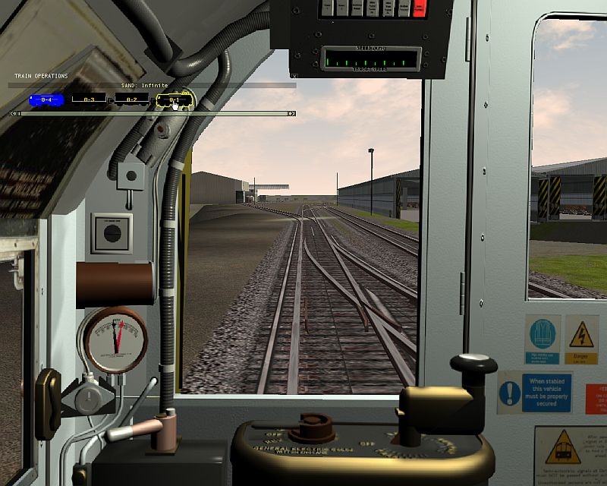
We start in the front cab in the front loco.
To change cabs (same loco) simply press the “1” key.
Note that the train must be motionless, and MSTS BIN sometimes complains if the train brake is not applied. Rather than apply the train brake (MSTS BIN sometimes fails to release the ‘helper loco brake’ later), instead apply a wagon handbrake (see related section below).

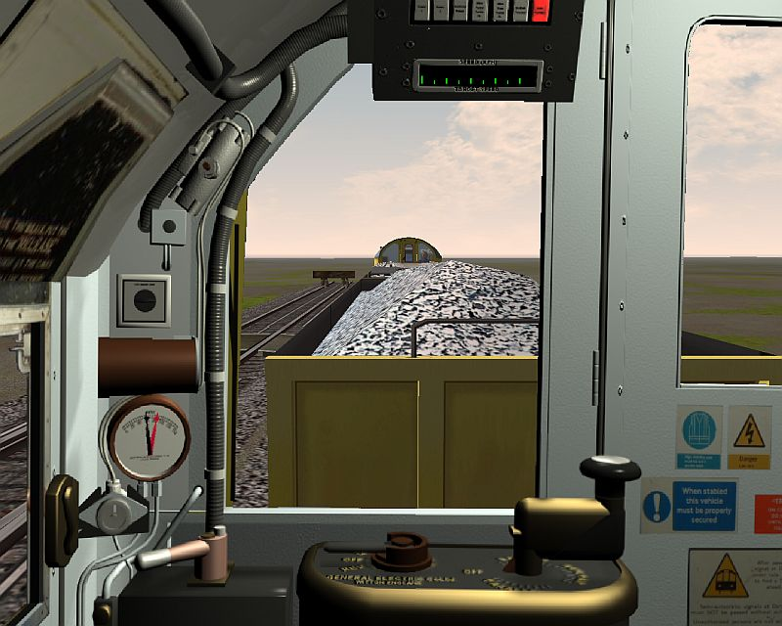
We’re now in the other-end cab of the same loco facing towards the rest of the train. We’d normally call that the rear of the train, however recall that as far as motoring is concerned, the direction you (the operator) are facing is Forwards.
To drive from this cab you need to turn on the lights, select FWD, release the brakes, etc. Don’t forget to release the wagon handbrake, if you set it to hold the train still. TransPlant does not like fixing wheel flats ☺ To return to the previous cab, press “1”.
You could also use this cab if you were approaching the wagons intending to couple, as you can see what you’re doing. Once coupled, switch cabs again and drive off…
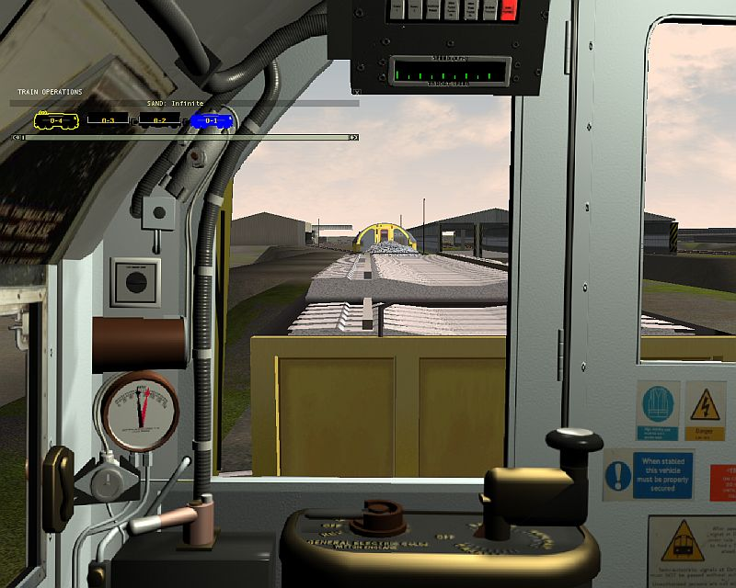
Start from the original cab again.
If instead you want to move to the forward-facing cab in the other loco, hit F9 to bring up the Train Operations display.
Click on the other loco (shown in blue).
Press “1”.
You will now be in the ‘front’ cab of the ‘rear’ loco facing forwards towards the original loco (see screenshot). It’s actually easier to do than describe.
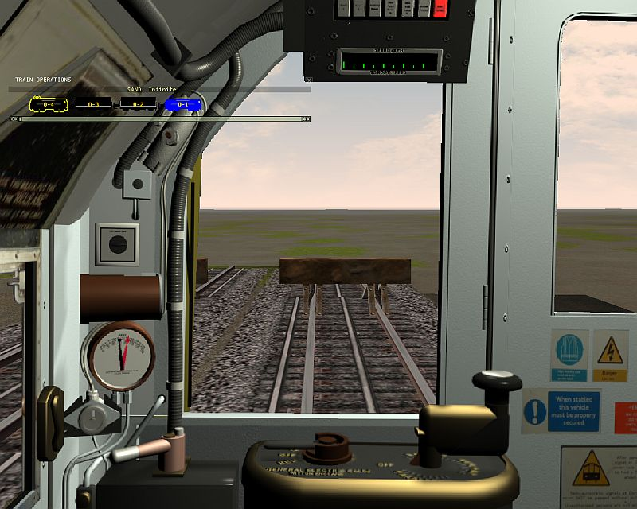
Finally, change to the other end cab in this loco.
Hit “1”.
We’re now facing out what used to be the rear cab of the rear loco. Clear? ☺
Spend some time trying it out and it will become obvious.
Being able to use either cab of a loco can make shunting and coupling operations much easier as you can see what you’re doing.
Summary: Hit “1” to change cabs. Hit F9 then “1” to change locos. Then lights on, FWD, Brakes off, etc.

COUPLING AND UN-COUPLING
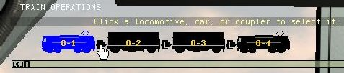
This is the first LUL stock we’ve produced that can actually couple and uncouple so it’s worth briefly describing how to do it successfully and safely. Much time was spent fine-tuning the loco and wagon couplers, buffers, etc. to get realistic operation. To couple to other units (e.g. a set of wagons), simply switch to the cab that faces them – so you can see what’s going on. Select FWD, release the brake and motor slowly towards the wagon at 2-3mph. CLUNK! Nice job.
To uncouple, hit F9 for the Train Operations display. Then double-click on the appropriate coupler. Set the wagon brake first!

TURBOT WAGON HANDBRAKES
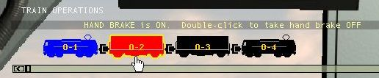
To set a wagon handbrake, hit F9 for the Train Operations display.
Then double-click on a wagon. It will turn red indicating the brake is applied.

TRAIN PHYSICS
Much time has been spent ensuring that the performance and behavior of the MSTS Battery Loco closely matches that of the real stock. When supplied with realistic data, the MSTS “physics engine” can produce very good results. This meant utilizing real values for such metrics as car weights and sizes, and determining the right aerodynamic drag and rail friction for the various units in the train set (thanks to Joe Realmuto’s FCALC2 program). The engine power, engine force (torque) and braking force were then be adjusted so as to achieve realistic acceleration, speed, and braking. Typical coasting behavior can also be achieved as a result of the train’s weight (momentum) and the drag/friction equations. Getting the couplers “right” also took a while ☺
Don’t forget you are driving a train that may weigh twice that of a typical LUL 6-car passenger set. The Battery Locos are powerful, but the laws of physics apply. The inertia and momentum of a heavier train are more pronounced. Moving off from rest will take longer, the effects of gradients will be different, and stopping will take more “thinking ahead” and care.
Some detailed aspects of the Battery Loco control systems can not be precisely modeled in MSTS. Similarly the precise behavior of the traction motors when using Series or Parallel motoring can not be exactly replicated. However, the effects of the real-life train systems have been simulated as closely as possible. Any exceptions to this relate to Kuju-imposed limitations in the Braking systems as discussed earlier.

EXAMPLE DRIVING PROCEDURES
The following are some example procedures that describe how to employ the controls to achieve the desired result. It is important to note that all speed limits and signals must be observed and obeyed, therefore you should always “look ahead” to anticipate any speed changes (acceleration or braking) that will be required.
You should consider the example procedures below as guidelines. The current line speed, gradients, home signaling and platform curvature (among other factors) will affect approach speed, braking points and brake rates to some degree. Using the example procedures shown below, coupled with knowledge of the line, will yield realistic train operation. One key point to remember is not to “drive the cab”. For example, before accelerating after crossing a turnout make sure the whole train is safely over – and not just your cab!

ACCELERATING IN GENERAL
When accelerating from rest it is most common in LUL passenger stocks to use Parallel motoring, so as to get up to line speed quickly. The Battery Loco is quite different, as it does not employ the automatic acceleration control system (notching relays and RPAs) that react to specific electrical current limits. Were you to go straight to a ‘high’ notch with the Battery Loco you would pop the LC breakers due to excessive current draw. You, the operator, are manually doing the work of that automatic current limiting system. This means starting in a low motoring position and gradually increasing the ‘notches’ as the train accelerates, so as to limit the current draw of the motors. The real Battery Locos do not have a cab Ammeter, so the operator must rely on experience. In the MSTS loco, no harm will come from using Parallel from rest – however it is not good driving and we suggest that part of the fun of this simulation is learning to do it the right way. Again, this is a heavy engineering train, and most things happen slowly and carefully.

COASTING IN GENERAL
Coasting is simply placing the MC in the Off notch and allowing the train to coast at the desired speed. Depending upon the gradient the train speed may decrease, increase, or remain about the same. On level track the speed will decay slowly due to aerodynamic drag and wheel friction, which are modeled. However given the train weight (momentum) the speed decay on level track will be quite gentle.

BRAKING IN GENERAL
A modest EP application is adequate to hold a train at rest on most gradients. Depending on the conditions and intentions, you may wish to apply one or more of the wagon handbrakes. Do not forget to release them when required – it is very embarrassing to try and pull away and either pop the LC breakers or flat a few wagon wheels. For a typical brake application (slowing or coming to a stand), you will add braking slowly and then apply more and more pressure as needed. This is because you cannot reduce the brake in the way that you can with the real system. To hold the brake pressure, move the lever to Hold. To release the brake go to Off.

SUMMARY
Operating the Battery Loco train efficiently will require practicing the above example procedures until you are comfortable with the train’s performance and know what to expect. Knowledge of the line is required so you can anticipate what actions may be required at various locations. Above all, have fun – driving the Battery Loco can be very rewarding one you have mastered the loco, its controls and the functions it can perform.
Welcome to the cab – we hope you enjoy the experience…
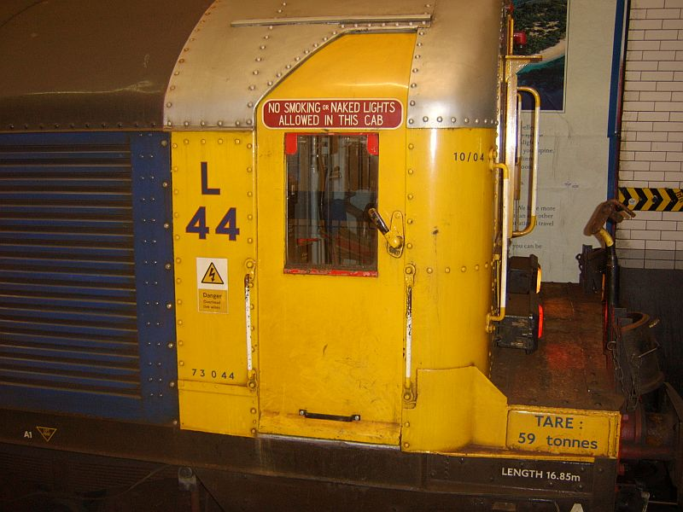

Notes, Acknowledgements & Credits
IMPORTANT NOTE: This train requires MSTS BIN for the cab/loco switching and the lighting systems to function correctly. It was tested with MSTS BIN Version 1.7.010302.

The Battery Loco units and the Turbot wagons were created by Richard Scott. Richard’s high-quality freeware models, as well as his commercial work for 3DTS, are well-known to the MSTS community. These models are likely among his most realistic work.
The detailed 3D cab and animated controls were developed using 3DS Max software by Darren Carter. He has the knack of capturing the atmosphere of the old train stock cabs perfectly, and it was again a pleasure to collaborate with Darren and Richard on a LUL Stock project.
I (Dr Jimi) was responsible for the controls/displays functionality, physics, sounds and lighting for the locos and wagons.

The train’s models, cab and realistic performance could not have been accomplished without the enthusiastic support and contributions of several LT/LUL professionals. We extend our sincere thanks to them for acting as technical consultants by sharing their knowledge and memories of “back in the day”.
Special thanks to “Doc” for supplying countless photos, videos and sound recordings; and to his TransPlant friends for their kind support.

We all hope you enjoy using this as much as we enjoyed creating it!

Photographs used herein are Copyright © 2007 by Doc, and are used with his kind permission.
LT Battery Loco Virtual Operator’s Guide. Document Copyright © 2007. Virtual District Line Team. All rights reserved.

